1. Write a prolog program for forward chaining

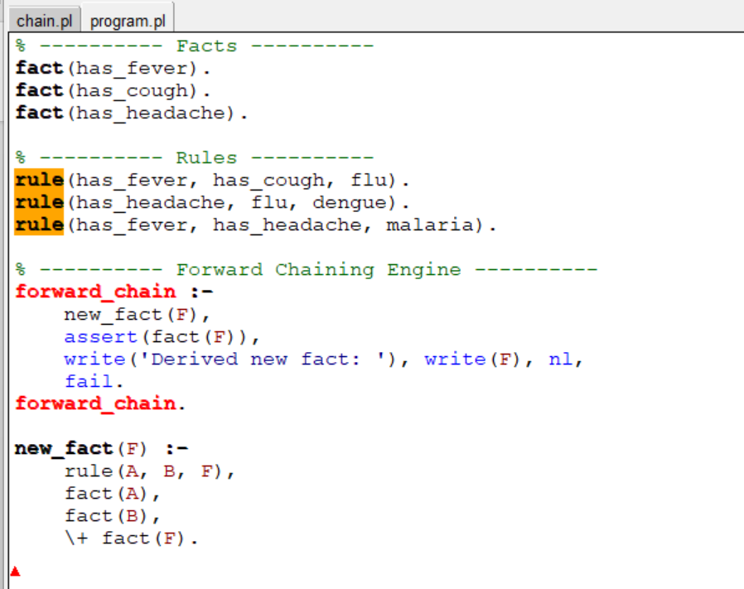

OUTPUT

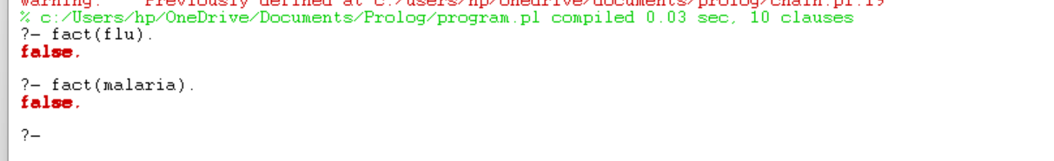

1. Prolog program for backward chaining

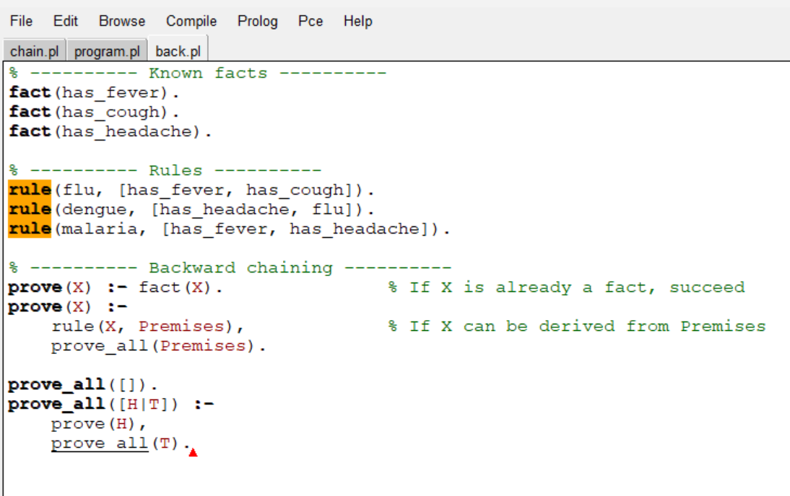

Output:

